Module name :black box and white box testing
Test case ID:ST_01
Webpage URL: www.automationexercise

Scenario ID : 1a

Scenario:Valid log-in
Test steps:

1.click on sign-up
2.Enter valid email id and password
3.click on sign-in

Screenshot:

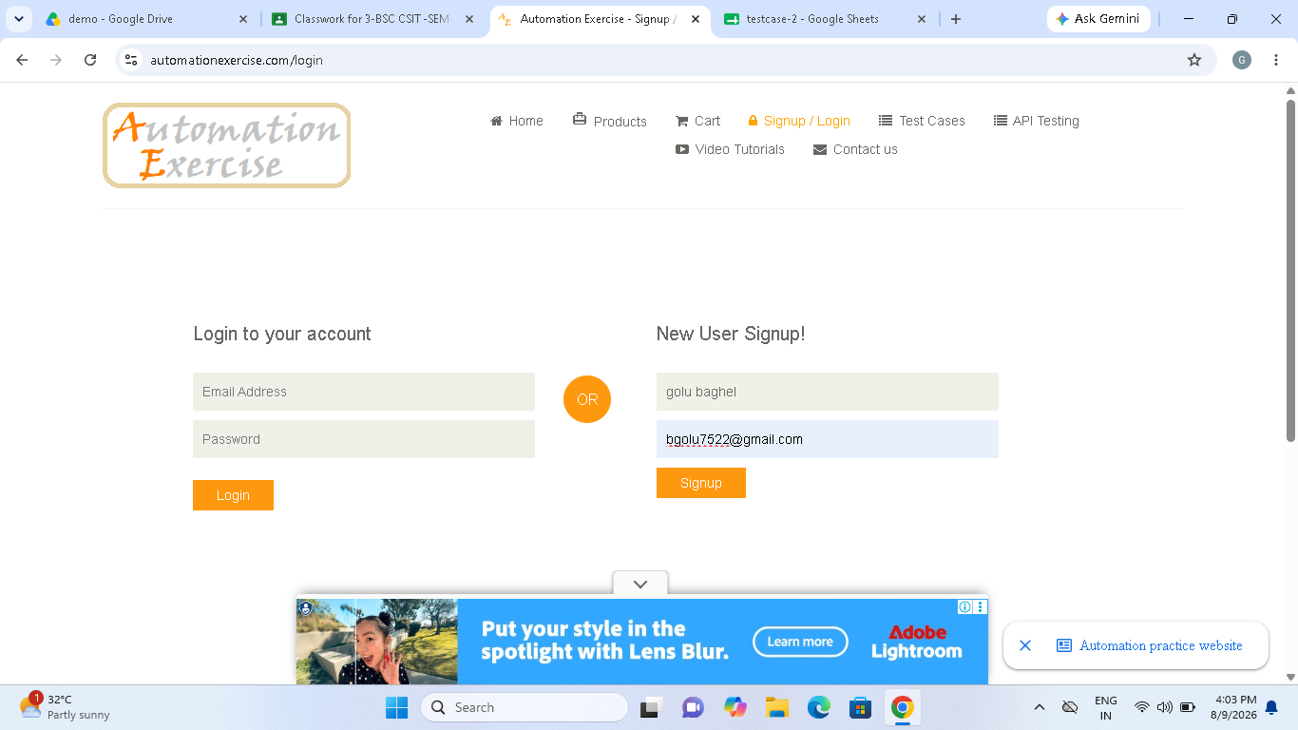

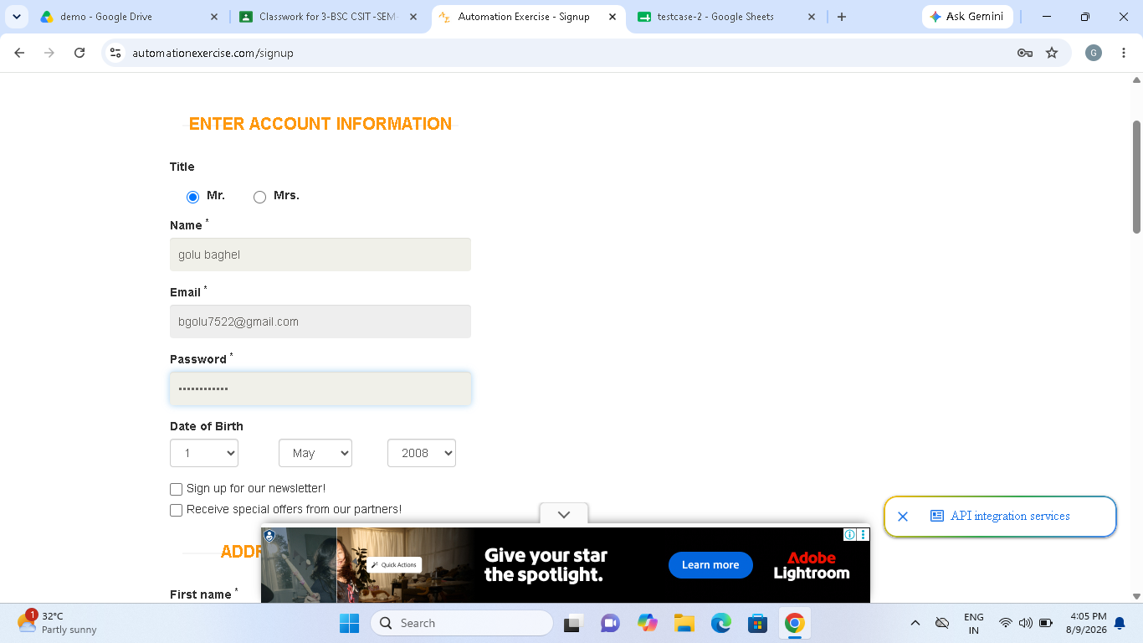

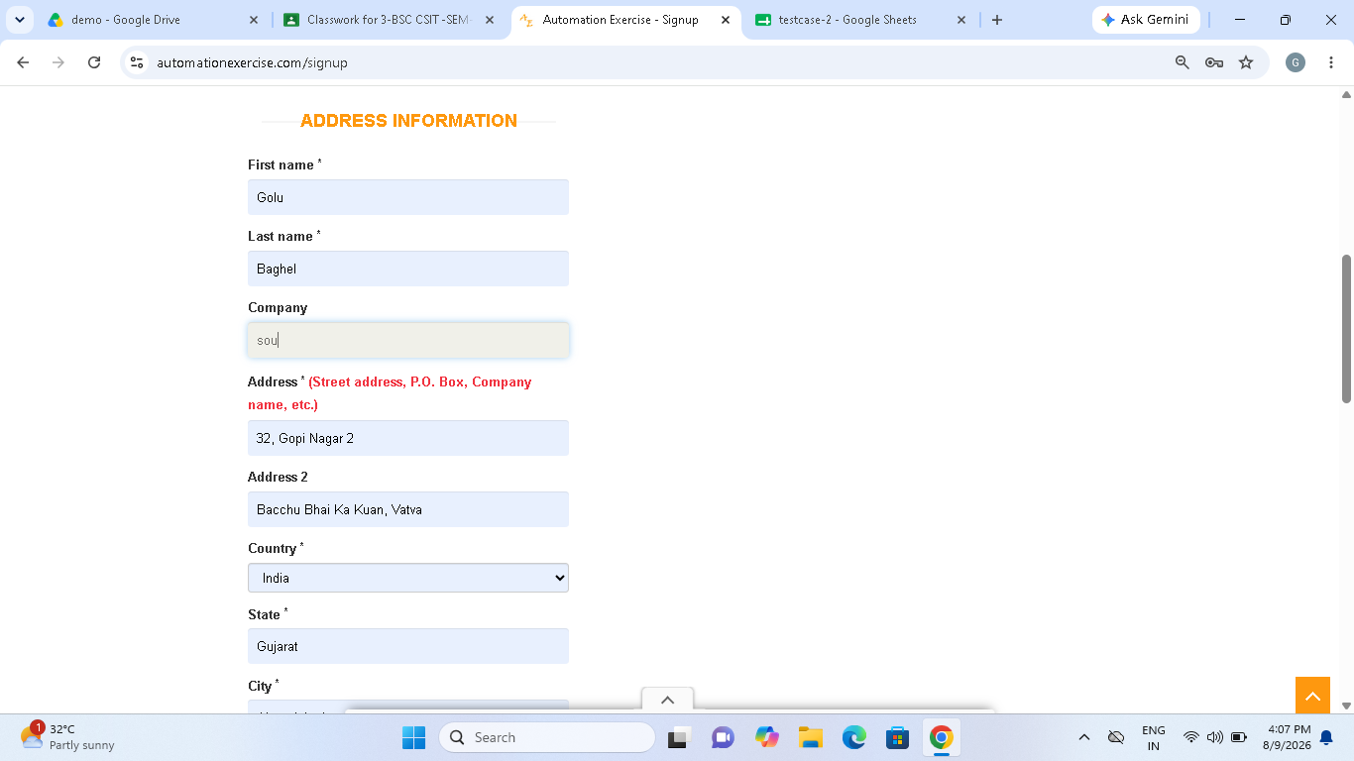

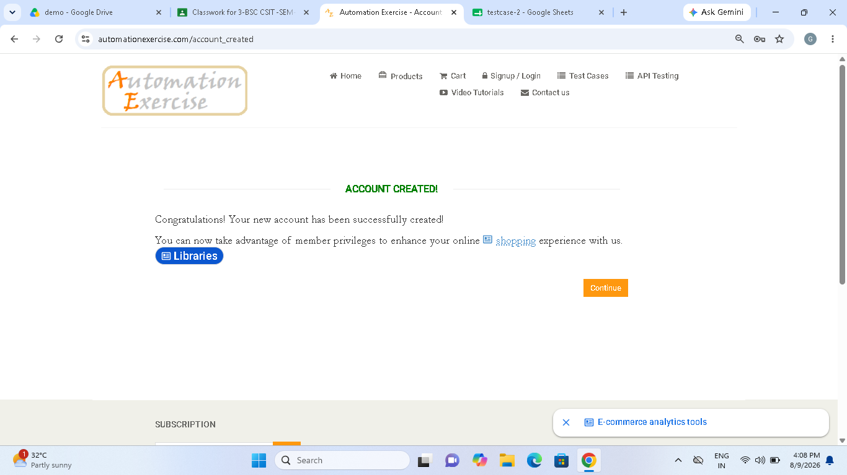

Scenario ID : 1b

Scenario: Invalid email
Test steps:
1.click on Log-in
2.Enter invalid email id
3.click on log-in

Screenshot:

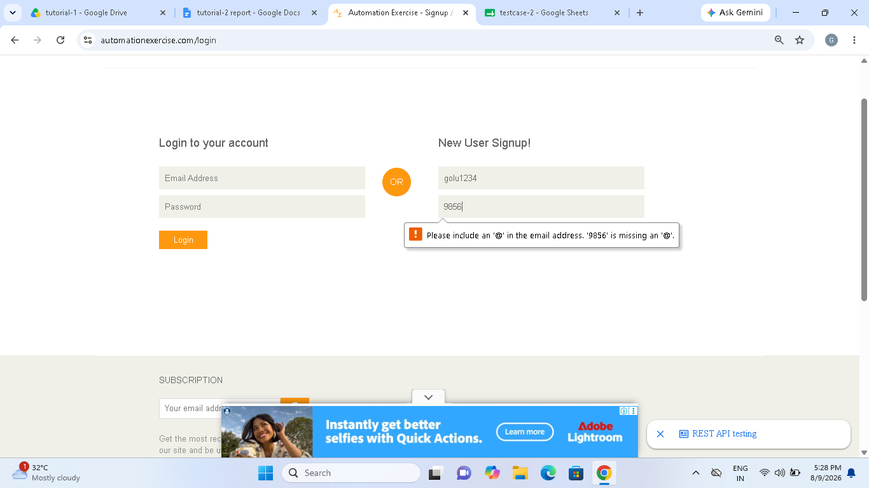

Scenario ID : 1c

Scenario: Invalid password
Test steps:
1.click on log-in
2.Enter valid email and invalid
password
3.click on log-in

Screenshot:

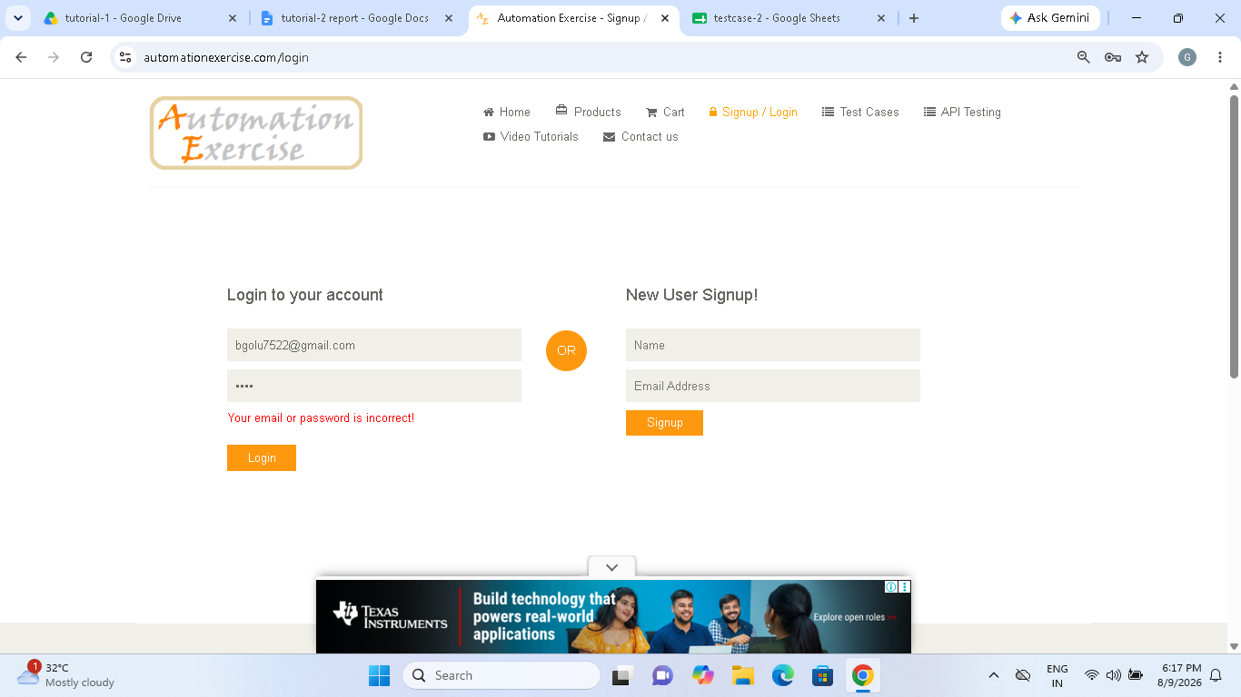

Scenario ID : 1d

Scenario: Both invalid
Test steps:
1.click on log-in
2.Enter invalid email and invalid
password
3.click on log-in

Screenshot:

Scenario ID : 1e

Scenario: Blank email
Test steps:
1.click on log-in
2. do not write e-mail
3.click on log-in

Screenshot:

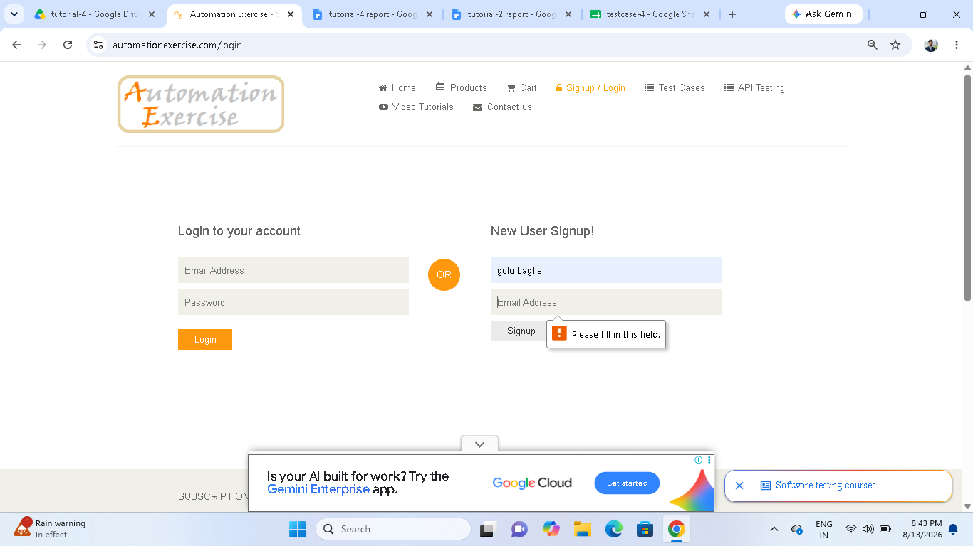

Scenario ID : 2a

Scenario: Blank password
Test steps:
1.click on Log-in
2.Enter valid email id
3.blank password
4.click on log-in

Screenshot:

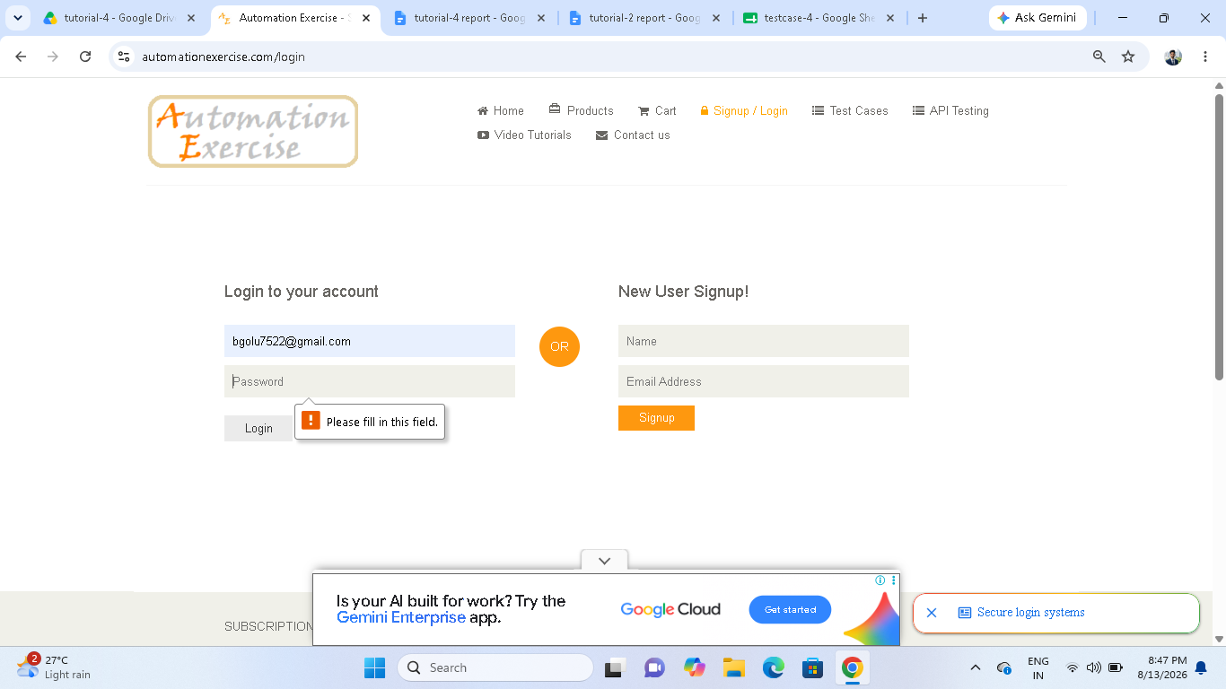

Scenario ID : 2b

Scenario: Both blank
Test steps:
1. do not write e-mail and password
2.click on sign-up

Screenshot:

